**Create an environment with a database**

You create a database to use Common Data Service as a data store. The Common Data Service is a cloud scale database used to securely store data for business applications built on Power Apps. Common Data Service provides not just data storage, but a way to implement business logic that enforces business rules and automation against the data.

**Prerequisites**

To create an environment with a database, you need 1GB available database capacity.

**Steps**

1. Sign in to the Power Platform admin center at [https://admin.powerplatform.microsoft.com](https://admin.powerplatform.microsoft.com/) as an admin (Dynamics 365 service admin, Global admin, or Power Platform service admin).
2. In the navigation pane, select **Environments**, and then select **New**.

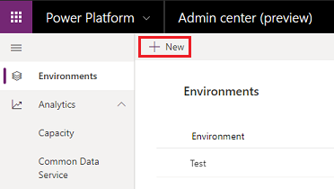

1. Enter the following, and then select **Next**.

| **TABLE 2** | |
| --- | --- |
| **Setting** | **Description** |
| Name | The name of your environment. |
| Type | Choose production, trial, or sandbox. |
| Region | Choose a region for the environment. |
| Purpose | A description of the environment. |
| Create a database for this environment? | Select **Yes**. |

1. 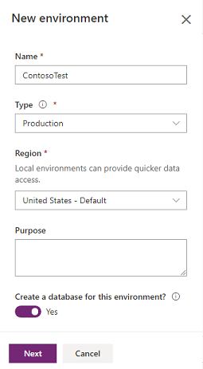
2. Enter the following, and then select **Save**.

| **TABLE 3** | |
| --- | --- |
| **Setting** | **Description** |
| Language | The default language for this environment. |
| Currency | The base currency used for reporting. |
| Enable Dynamics 365 apps | Select **Yes** and make a selection to automatically deploy apps such as Dynamics 365 Sales and Dynamics 365 Customer Service. |
| Deploy sample apps and data | Select **Yes** to include sample apps and data. Sample data gives you something to experiment with as you learn. You must select **No** for **Enable Dynamics 365 apps** for this setting to appear. |
| Security group | Select a security group to restrict access to this environment. |

1. 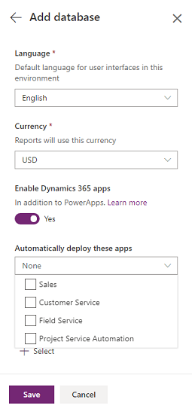

**Create an environment without a database**

You can create an environment without a database and use your own data store.

**Prerequisites**

You need 1GB available database capacity.

**Steps**

1. Sign in to the Power Platform admin center at [https://admin.powerplatform.microsoft.com](https://admin.powerplatform.microsoft.com/) as an admin (Dynamics 365 service admin, Global admin, or Power Platform service admin).
2. In the navigation pane, select **Environments**, and then select **New**.



1. Enter the following, and then select **Save**.

| **TABLE 4** | |
| --- | --- |
| **Setting** | **Description** |
| Name | The name of your environment. |
| Type | You can choose production or trial. |
| Region | Choose a region for the environment. |
| Purpose | A description of the environment. |
| Create a database for this environment? | Select **No**. |

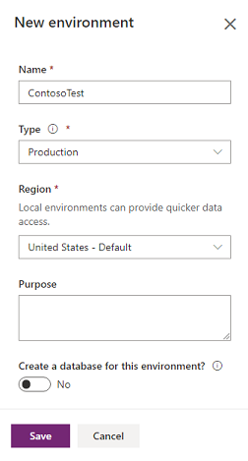

**Provision a sandbox environment**

To provision a [sandbox environment](https://docs.microsoft.com/en-us/power-platform/admin/sandbox-environments), you change a production environment to sandbox.

1. Sign in to the Power Platform admin center at [https://admin.powerplatform.microsoft.com](https://admin.powerplatform.microsoft.com/) as an admin (Dynamics 365 service admin, Global admin, or Power Platform service admin).
2. From the left-side menu, select **Environments**, and then select a production environment.
3. Select **Edit**

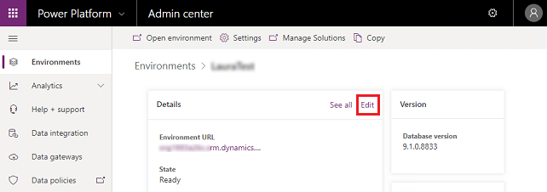

1. Under **Type**, choose the sandbox environment type.

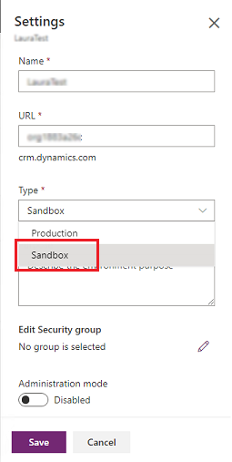

1. Select **Save**.